28. (a)

Payoff matrix:
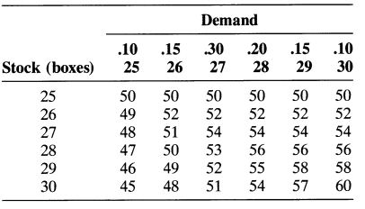
(b)

V(25) = 50(.10) + 50(.15) + 50(.30) + 50(.20)+ 50(.15) + 50(.10) = 50.0; EV(26) = 49(.10) +52(.15) + 52(.30) + 52(.20) + 52(.15) + 52(.10)= 51.7; EV(27) = 48(.10) + 51(.15) + 54(.30) +54(.20) + 54(.15) + 54(.10) = 52.95; EV(28) =47(.10) + 50(.15) + 53(.30) + 56(.20) + 56(.15)+ 56(.10) = 53.3; EV(29) = 46(.10) + 49(.15) +52(.30) + 55(.20) + 58(.15) + 58(.10) = 53.05; EV(30) = 45(.10) + 48(.15) + 51(.30) + 54(.20)+ 57(.15) + 60(.10) = 52.35;
Since EV (28) =$53.30 is the maximum, 28 boxes of Christmas cards should be stocked.

(c)
Compute expected value under certainty:

EV=50(.10) + 52(.15) + 54(.30) + 56(.20) + 58(.15) + 60(.10) = $54.90; EVPI = $54.90 – $53.30 =$1.60

30. (a) Stock 25, maximum of minimum payoffs = $50

(b) Stock 30, maximum of maximum payoffs =$60

(c)
25: 50(.4) + 50(.6) = 50; 26: 52(.4) + 49(.6) =50.2; 27: 54(.4) + 48(.6) = 50.4; 28: 56(.4) +47(.6) = 50.6; 29: 58(.4) + 46(.6) = 50.8; 30:60(.4) + 45(.6) = 51; stock 30 boxes.

(d) Stock 28 or 29 boxes; minimum regret = $4

